Deepak.P
251901032
METASPLOIT

Ex. No.: 8
Aim:
To set up Metasploit framework and exploit reverse_tcp in Windows 8 machine remotely.
Algorithm:
1. Generate payload to be inserted into the remote machine
2. Set the LHOST and it’s port number
3. Open msfconsole.
4. Use exploit/multi/handler
5. Establish reverse_tcp with the remote windows 8 machine.
6. Run SimpleHTTPServer with port number 8000.
7. Open the web browser in Windows 8 machine and type http://172.16.8.155:8000 8. In KaliLinux, type sysinfo to get the information about Windows 8 machine 9. Create a new directory using mkdir command.
10.Delete the created directory.
Output:
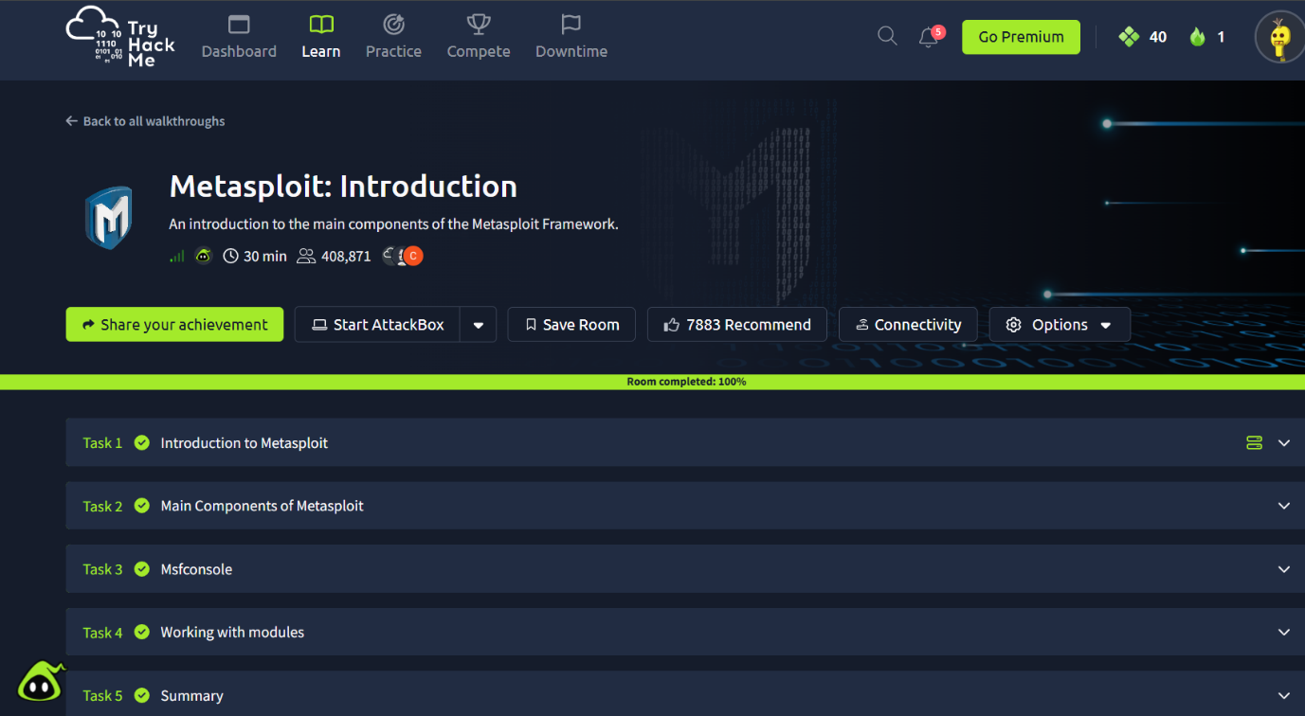
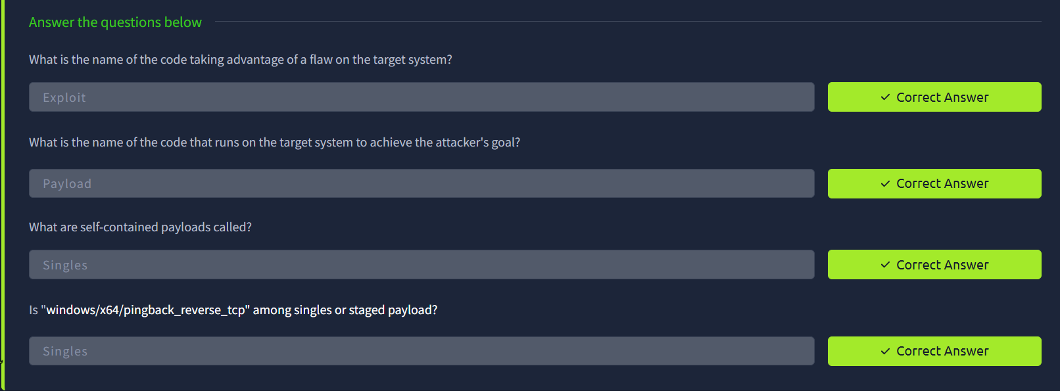
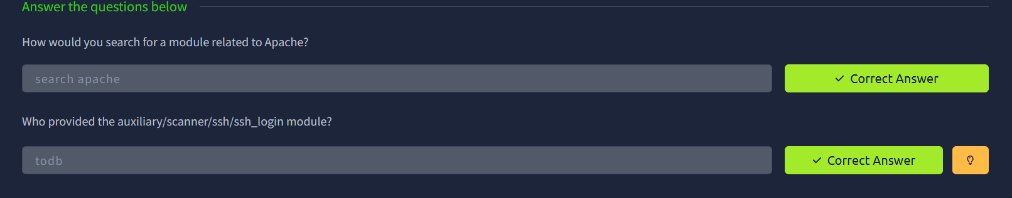
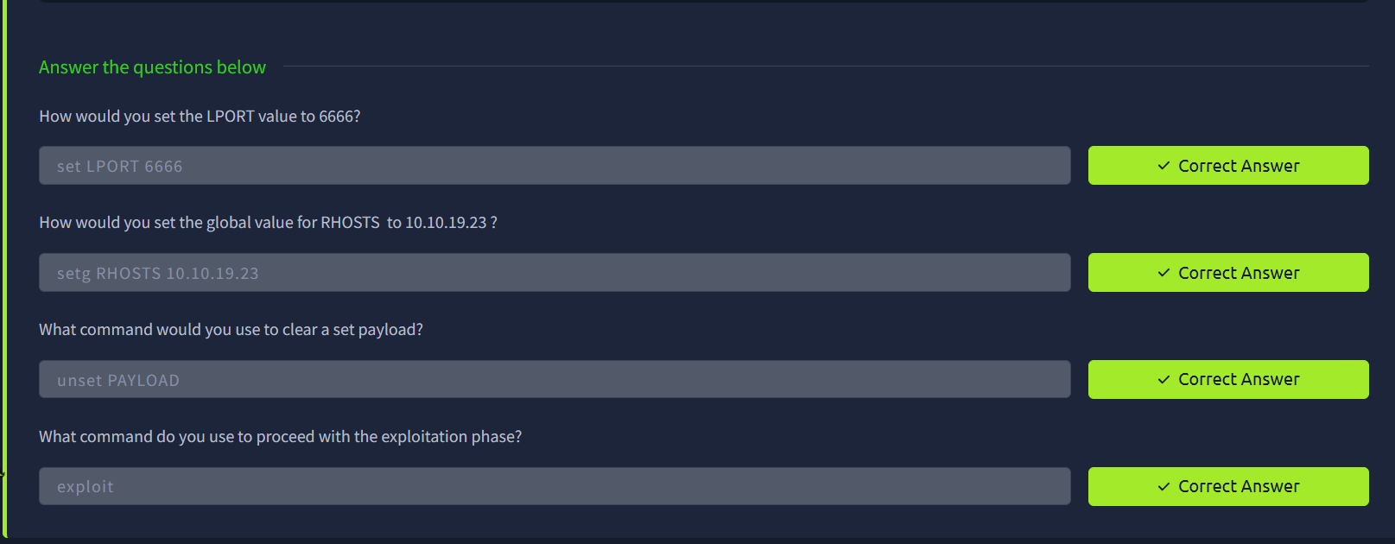

Result: Thus, the setup of Metasploit framework and exploit reverse_tcp in Windows 8 machine remotely has been executed successfully.

